# Initialisation du projet :

1. Analyse des routes existantes

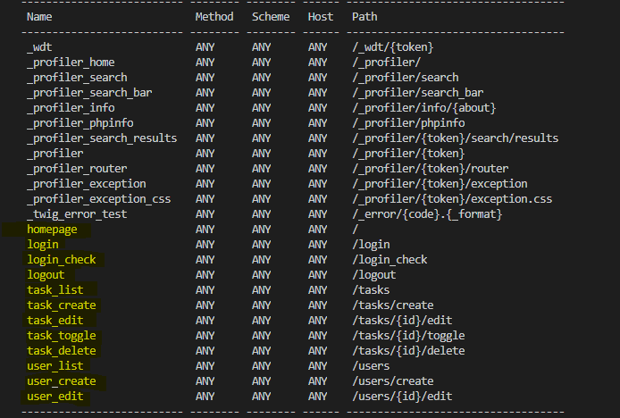

1. Analyse PHPUnit Init Project :

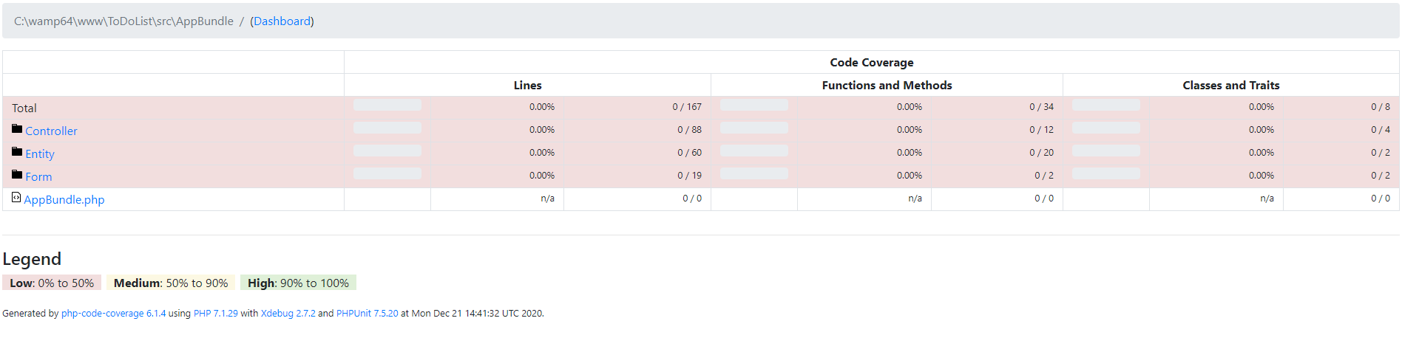

1. Analyses Blackfire Init :

[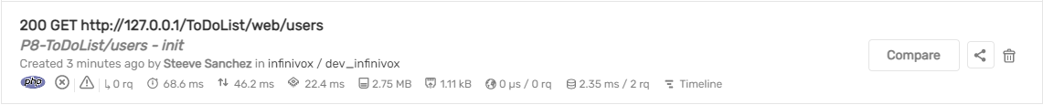](https://blackfire.io/profiles/00776496-5591-4933-9faa-652829725ad2/graph?settings%5Bdimension%5D=wt&settings%5Bdisplay%5D=landscape&settings%5BtabPane%5D=nodes&selected=&callname=main())

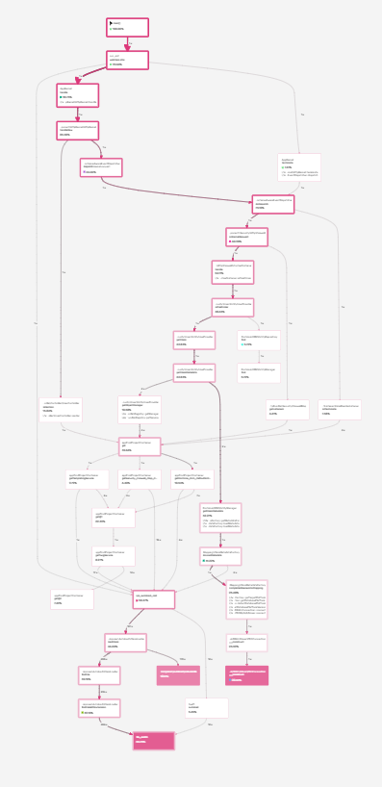

[Analyse de la route => http://127.0.0.1/ToDoList/tasks](https://blackfire.io/profiles/27eb7b73-4dcc-4e81-a177-19fa75359fdd/graph?settings%5Bdimension%5D=wt&settings%5Bdisplay%5D=landscape&settings%5BtabPane%5D=nodes&selected=&callname=main())

